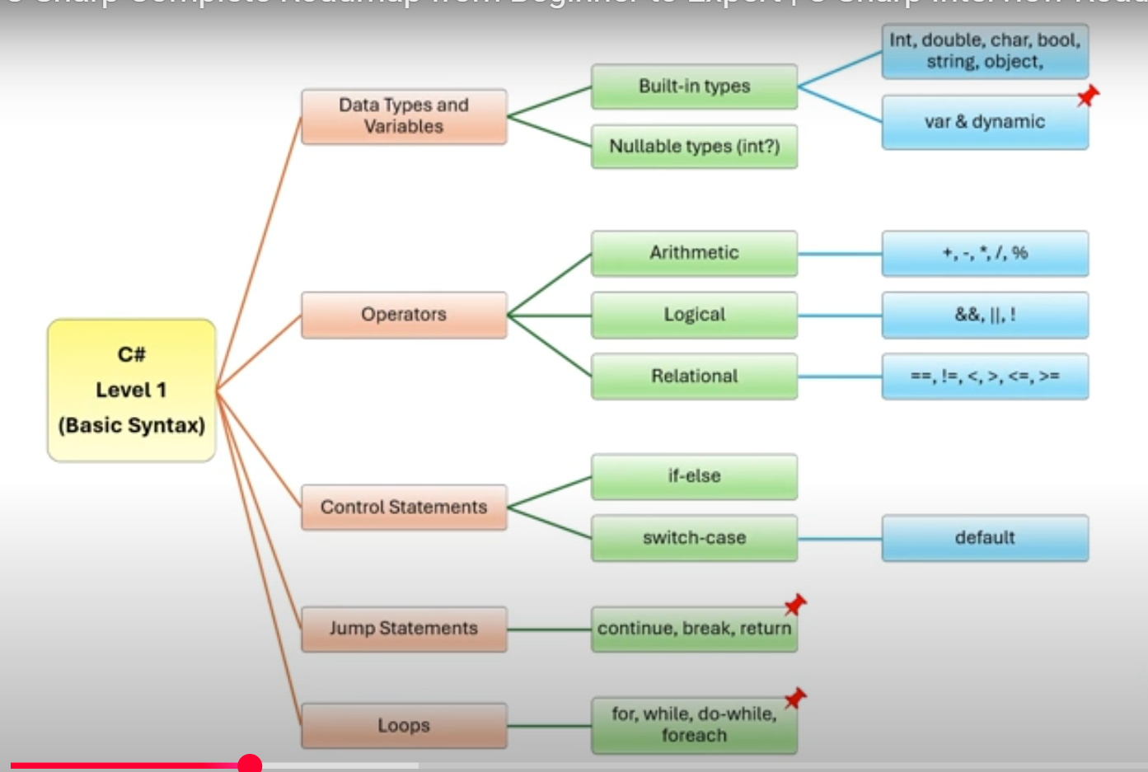

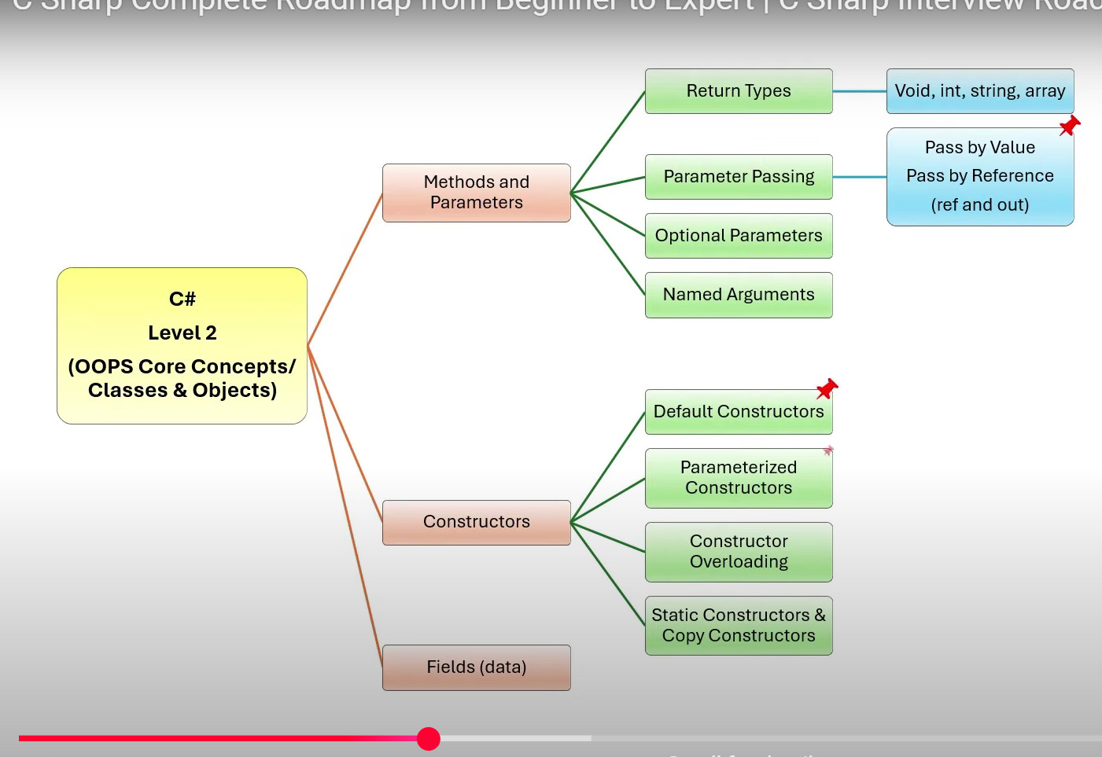

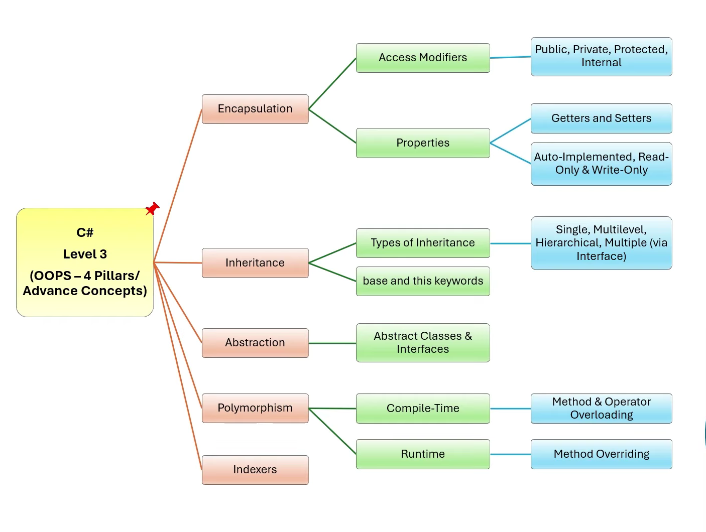

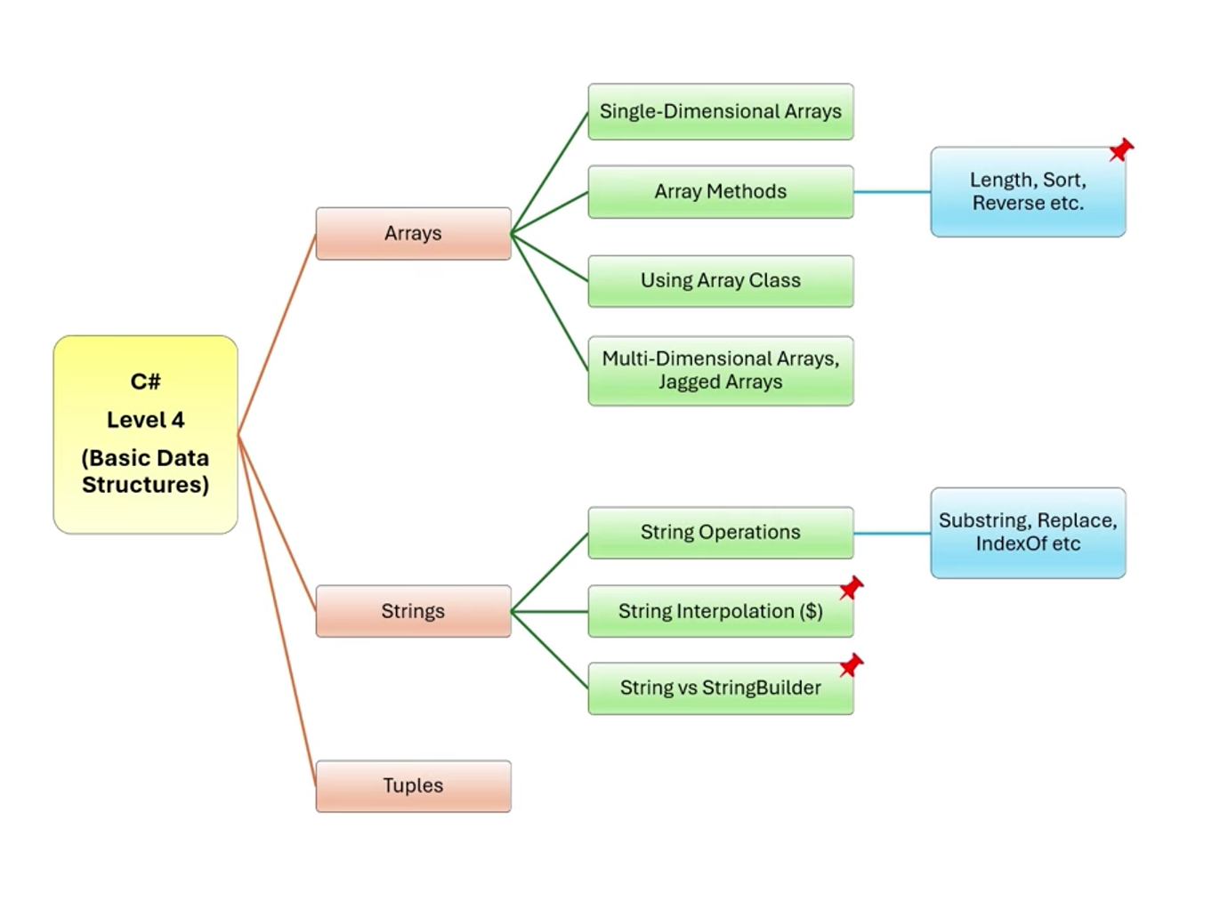

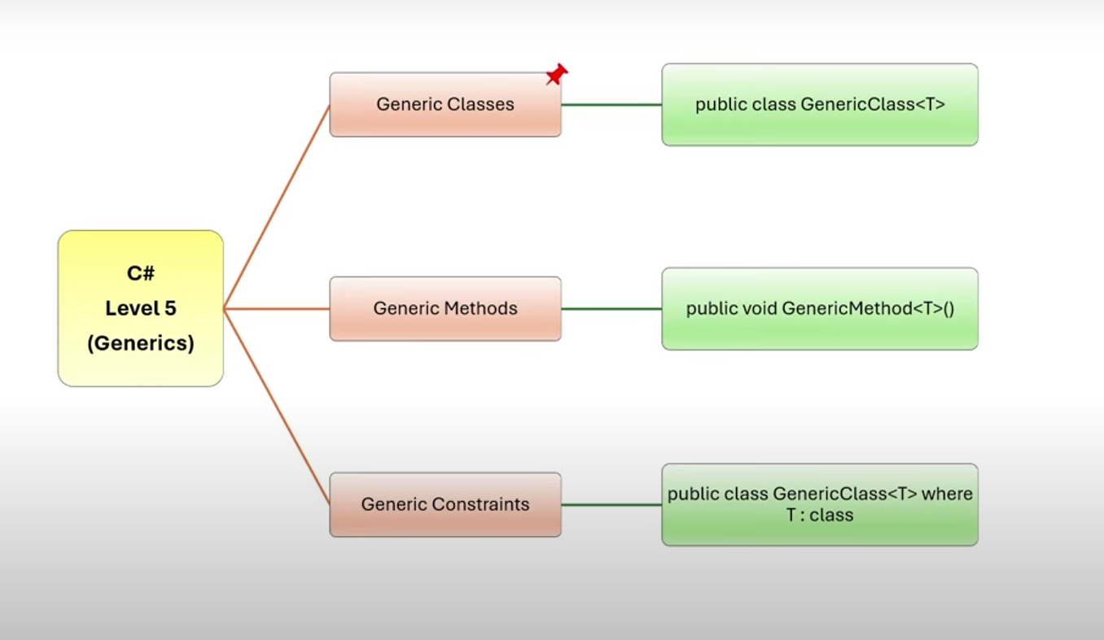

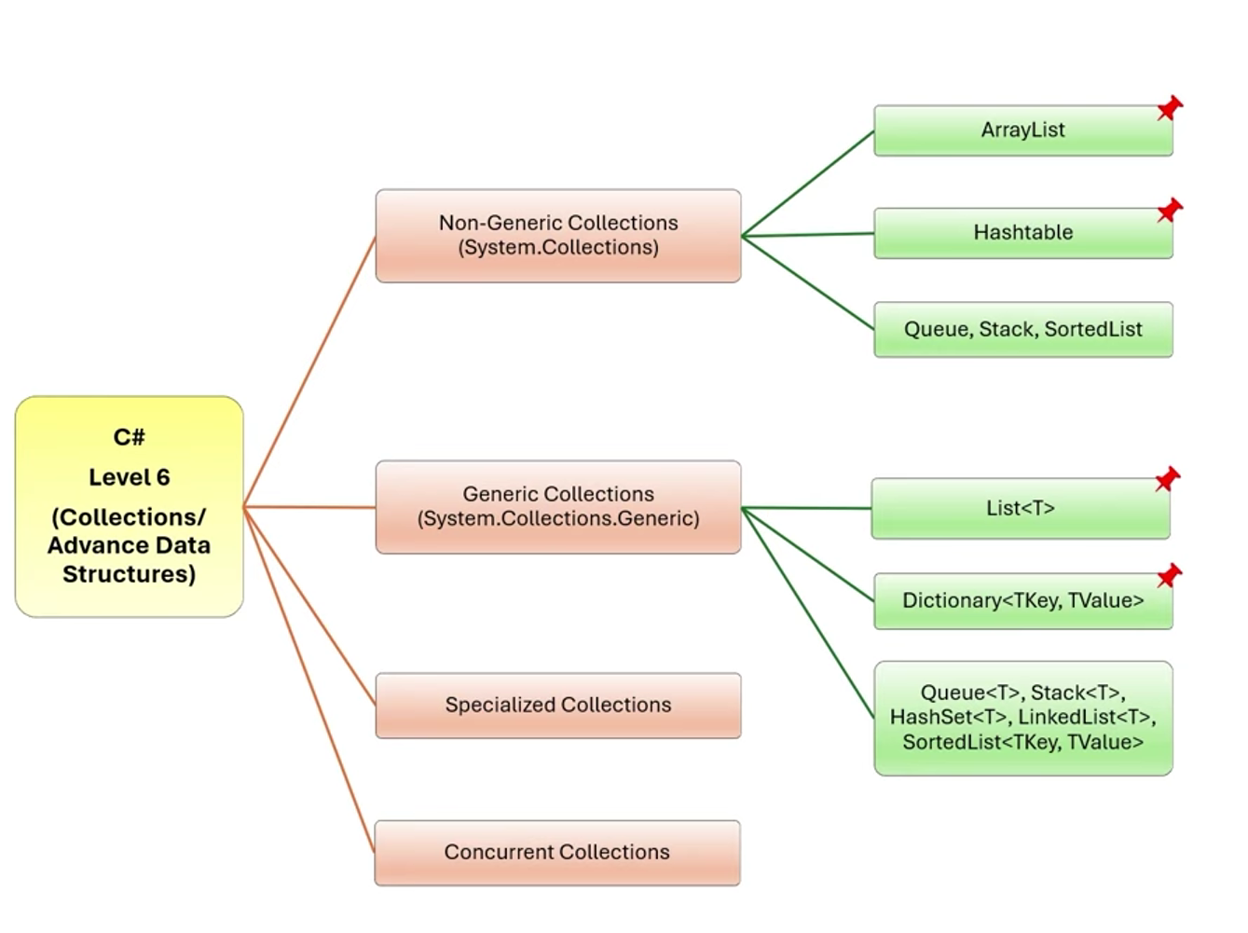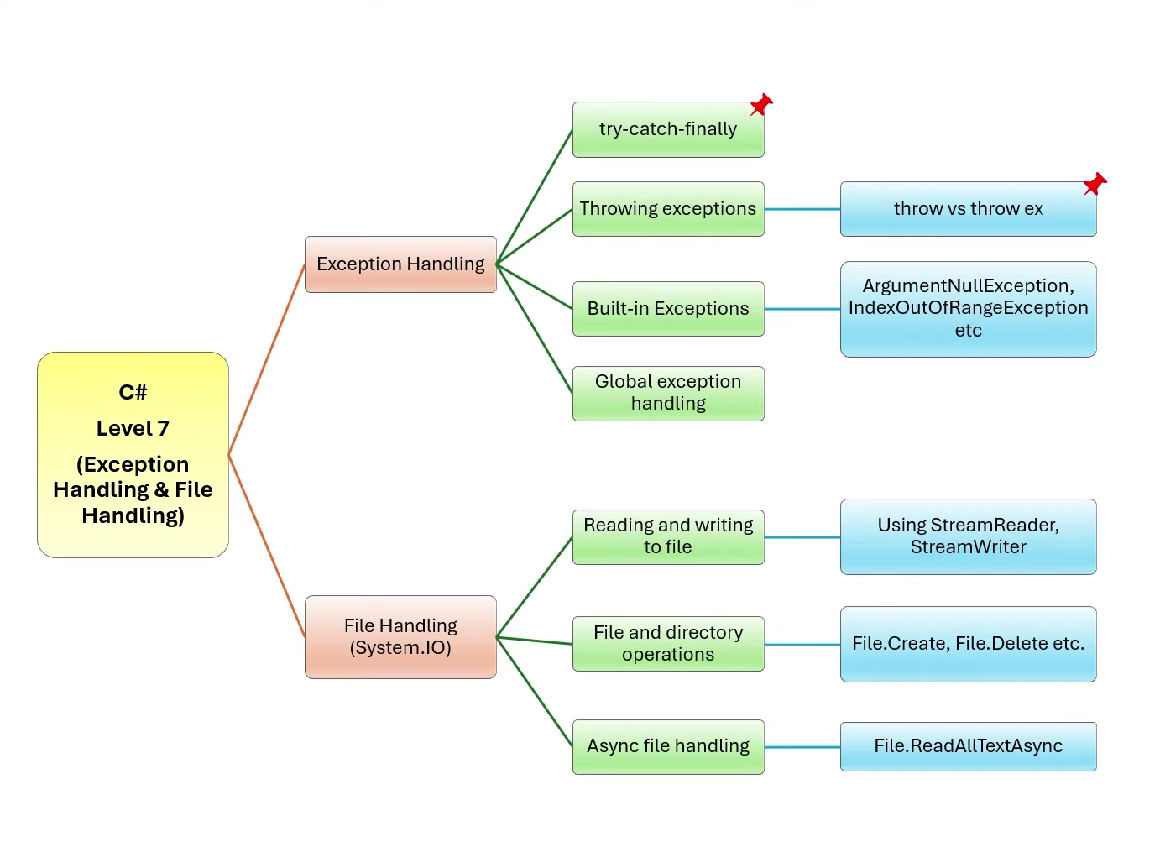
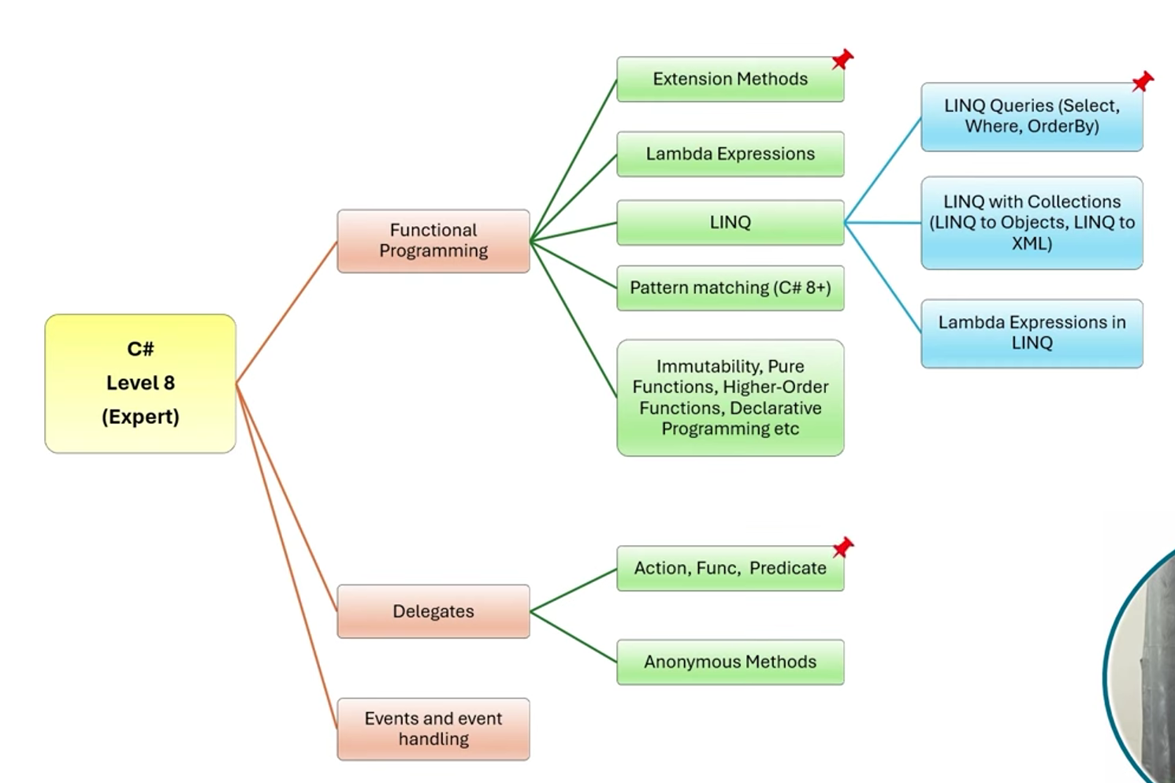

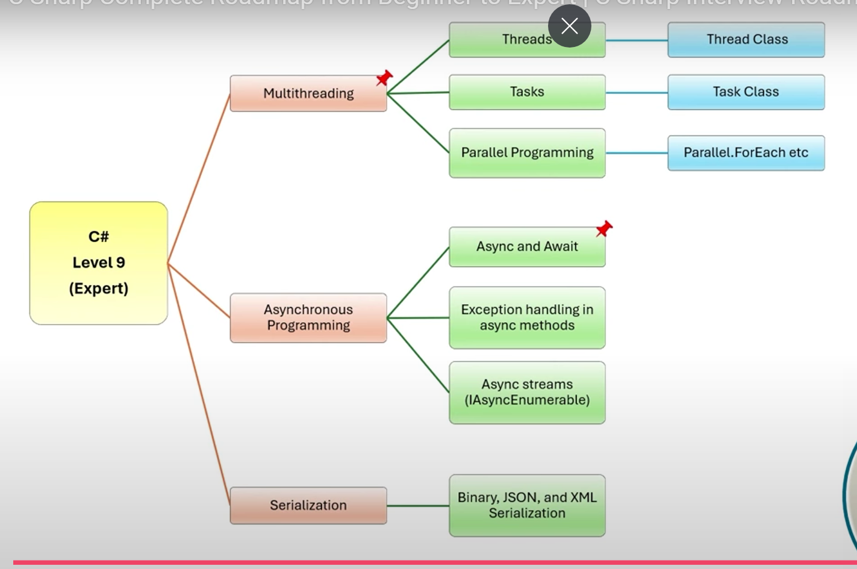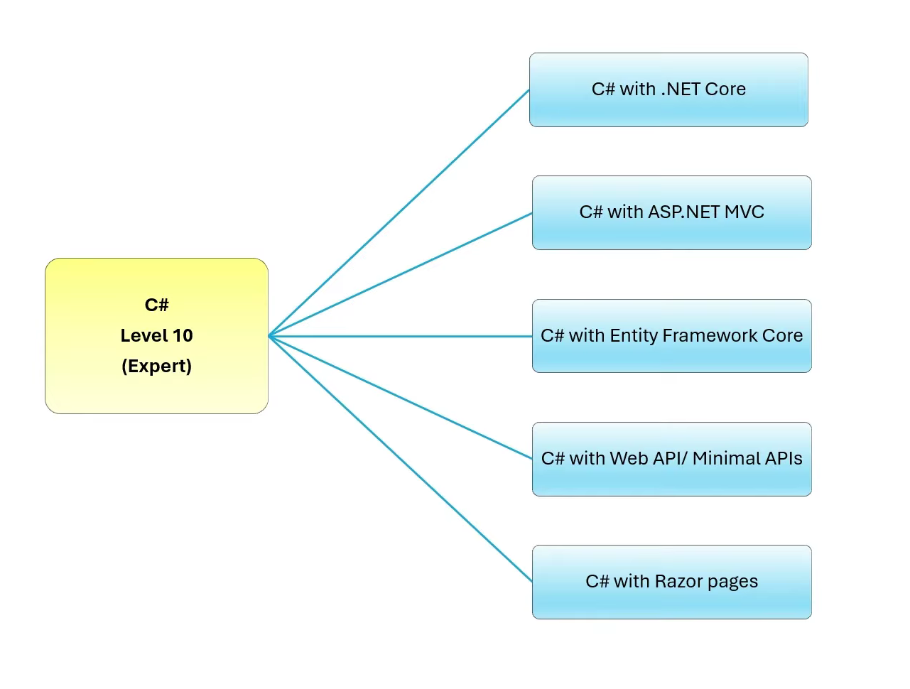

1.Types of classes:
Abstract class
Static class
Sealed class
Partial class
Generic class
Nested class

2. Is it possible to prevent object creation of a class in C#?
Yes, but using abstract class we can’t do that and by make a constructor of the class private or protected. This way, the class cannot be instantiated from outside the class itself

3.Property?
property is a member of a class that provides a flexible mechanism to read, write, or compute the value of a private field
4.property and function
- Access vs. Action: Properties are primarily for accessing and modifying data, while functions are for performing actions or computations.
- Syntax: Properties use get and set accessors, whereas functions use method declarations with parameters and return types.
- Usage: Properties are accessed like fields, while functions are called like methods.
5. Are private class members inherited to the derived class?
public class BaseClass
{
private int privateField = 10;

public int GetPrivateField()
{
return privateField;
}
}

public class DerivedClass : BaseClass
{
public void ShowPrivateField()
{
// Cannot access privateField directly
// Console.WriteLine(privateField); // This will cause a compile-time error

// Can access privateField through a public method
Console.WriteLine(GetPrivateField());
}
}
6. If two methods have same except return type, then methods are overloaded?

public class Example
{
// This method returns an int
public int DoSomething(int a)
{
return a + 1;
}

// This method returns a string
public string DoSomething(int a)
{
return "Number: " + a;
}
}
The above code will cause a compile-time error because the methods DoSomething have the same parameter list but different return types. To overload methods correctly, you need to change the parameters:
7. Method is marked as virtual,do we have to "override" it from the child base
- DerivedClass overrides the Display method, providing its own implementation.
- AnotherDerivedClass does not override the Display method, so it will use the implementation from BaseClass.
8. Can you declare abstract methods as private in C#?
No, you cannot declare abstract methods as private in C#. Abstract methods are meant to be overridden in derived classes, and for this to be possible, they need to be accessible to those derived classes. Therefore, abstract methods must be declared with either protected or public access modifiers.

9. If base & child both class have constructors, which will be called first?
In C#, when both the base class and the derived class have constructors, the base class constructor is called first, followed by the derived class constructor. This ensures that the base class is properly initialized before the derived class adds its own initialization.

10.

